Evidence for Project Unit

Ross Hill

Cohort E18

**P1 – Contributors Page**

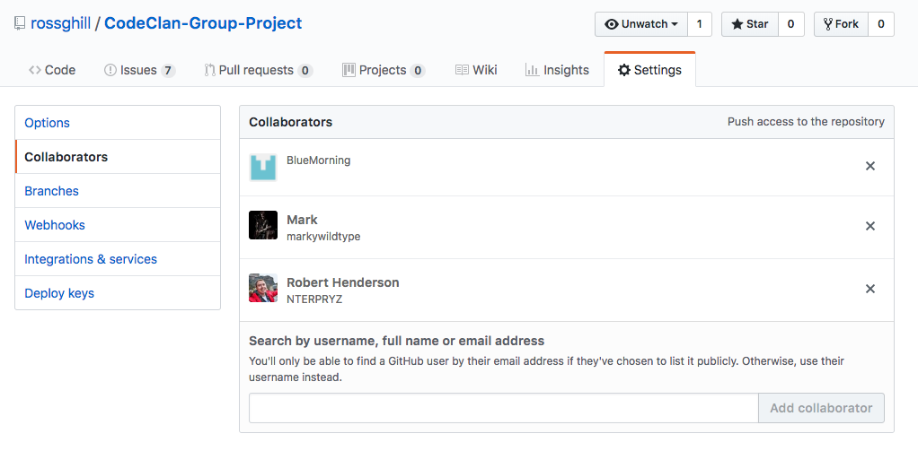

**P2 – Project Brief**

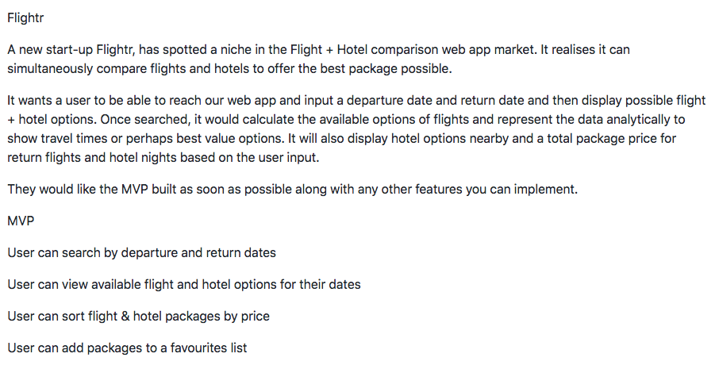

**P3 – Project Planning**

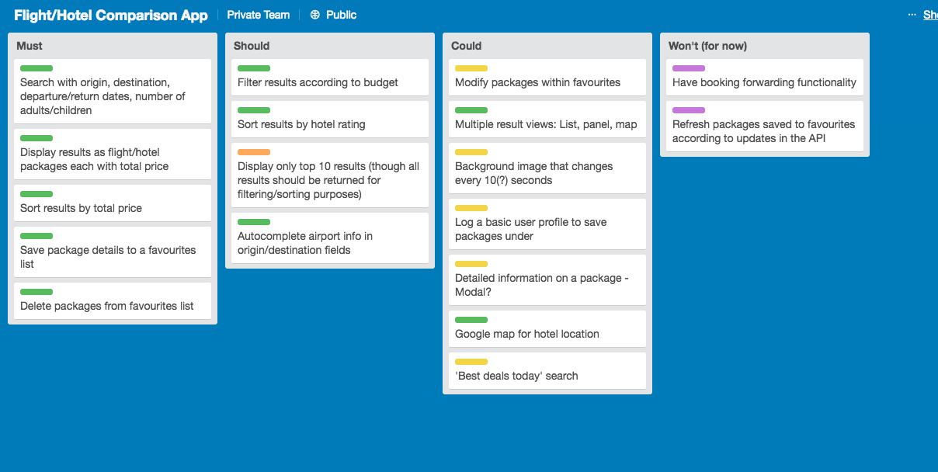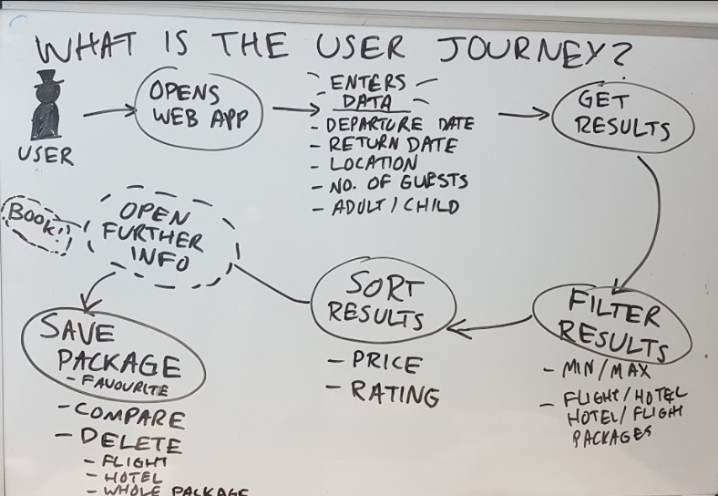

**P4 – Acceptance criteria/ Test Plan**

**P5 – User sitemap**

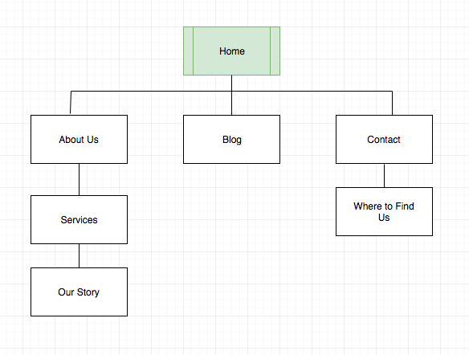

**P6 – Wireframe designs**

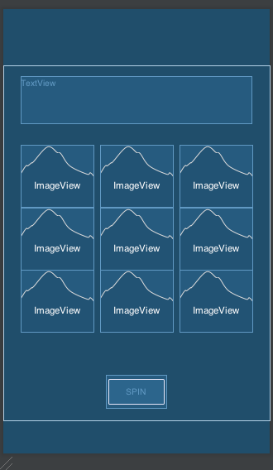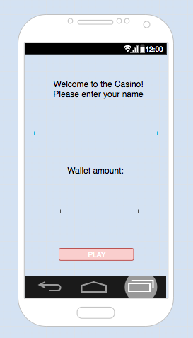

**P7 – System interaction diagrams**

**P8 – Object diagrams**

**P9 – Algorithms**

**P10 – Pseudocode**

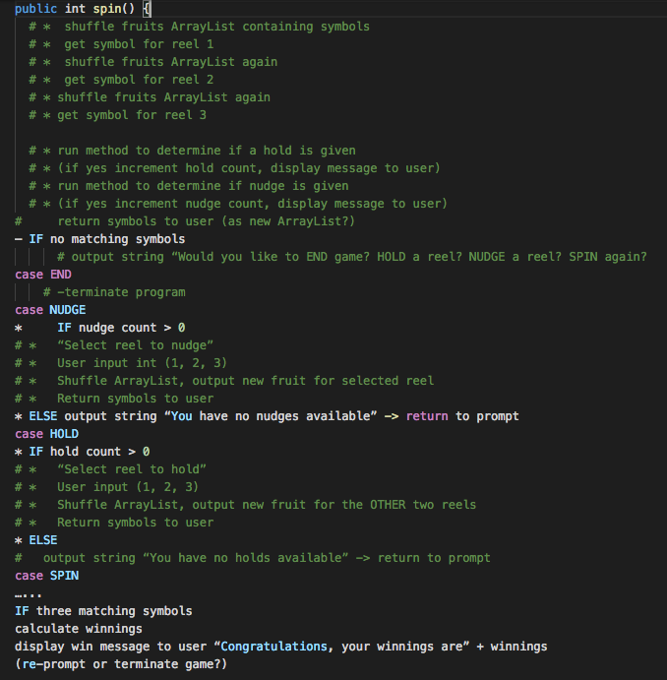

**P11 – Solo Project**

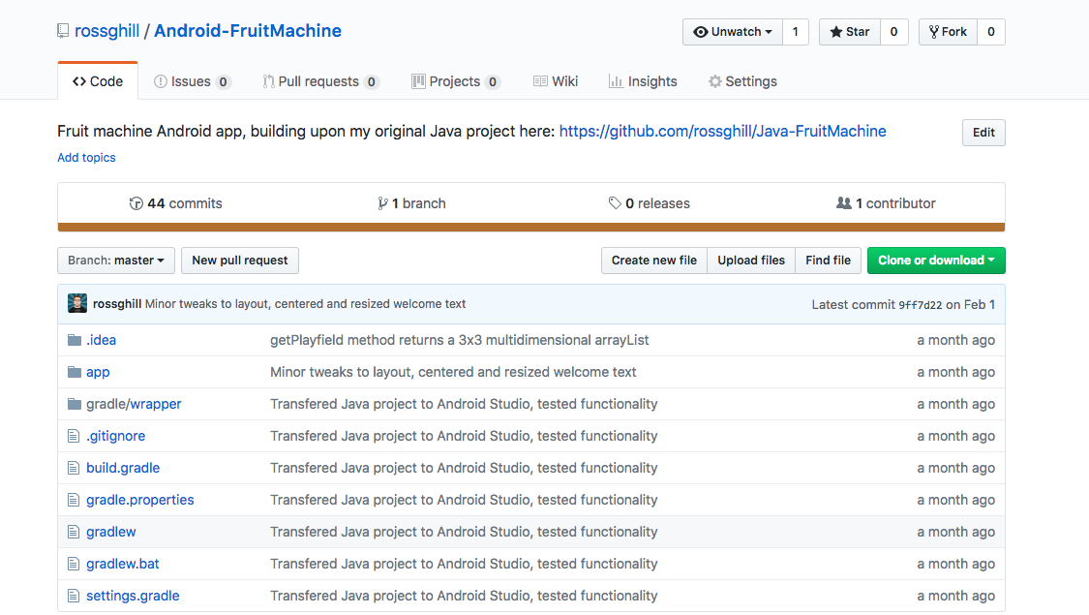

**https://github.com/rossghill/Android-FruitMachine**

**P12 – Planning and Development**

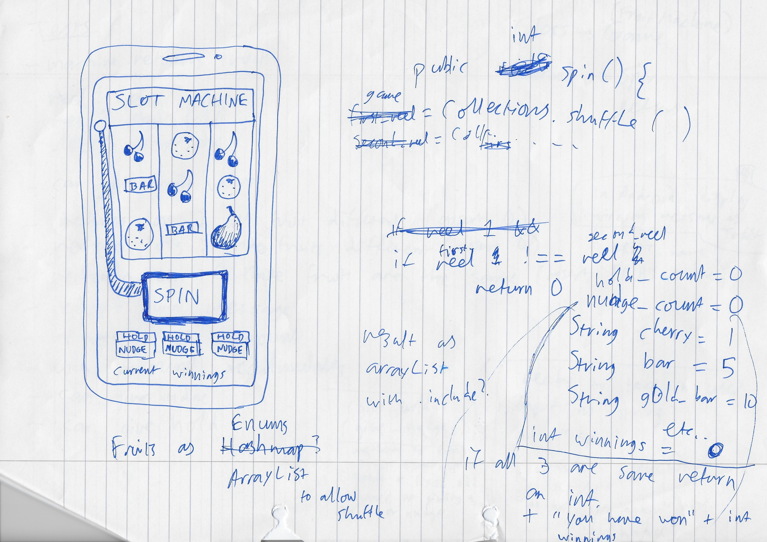

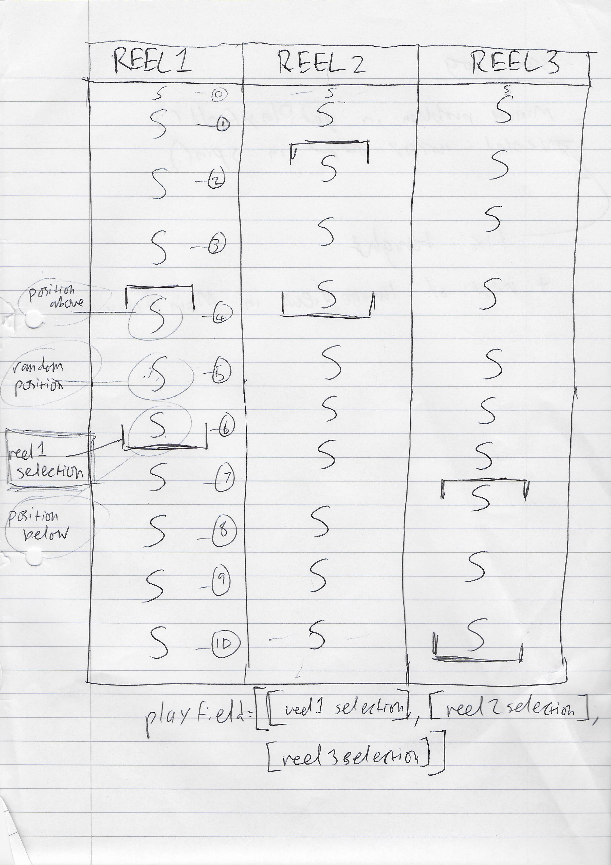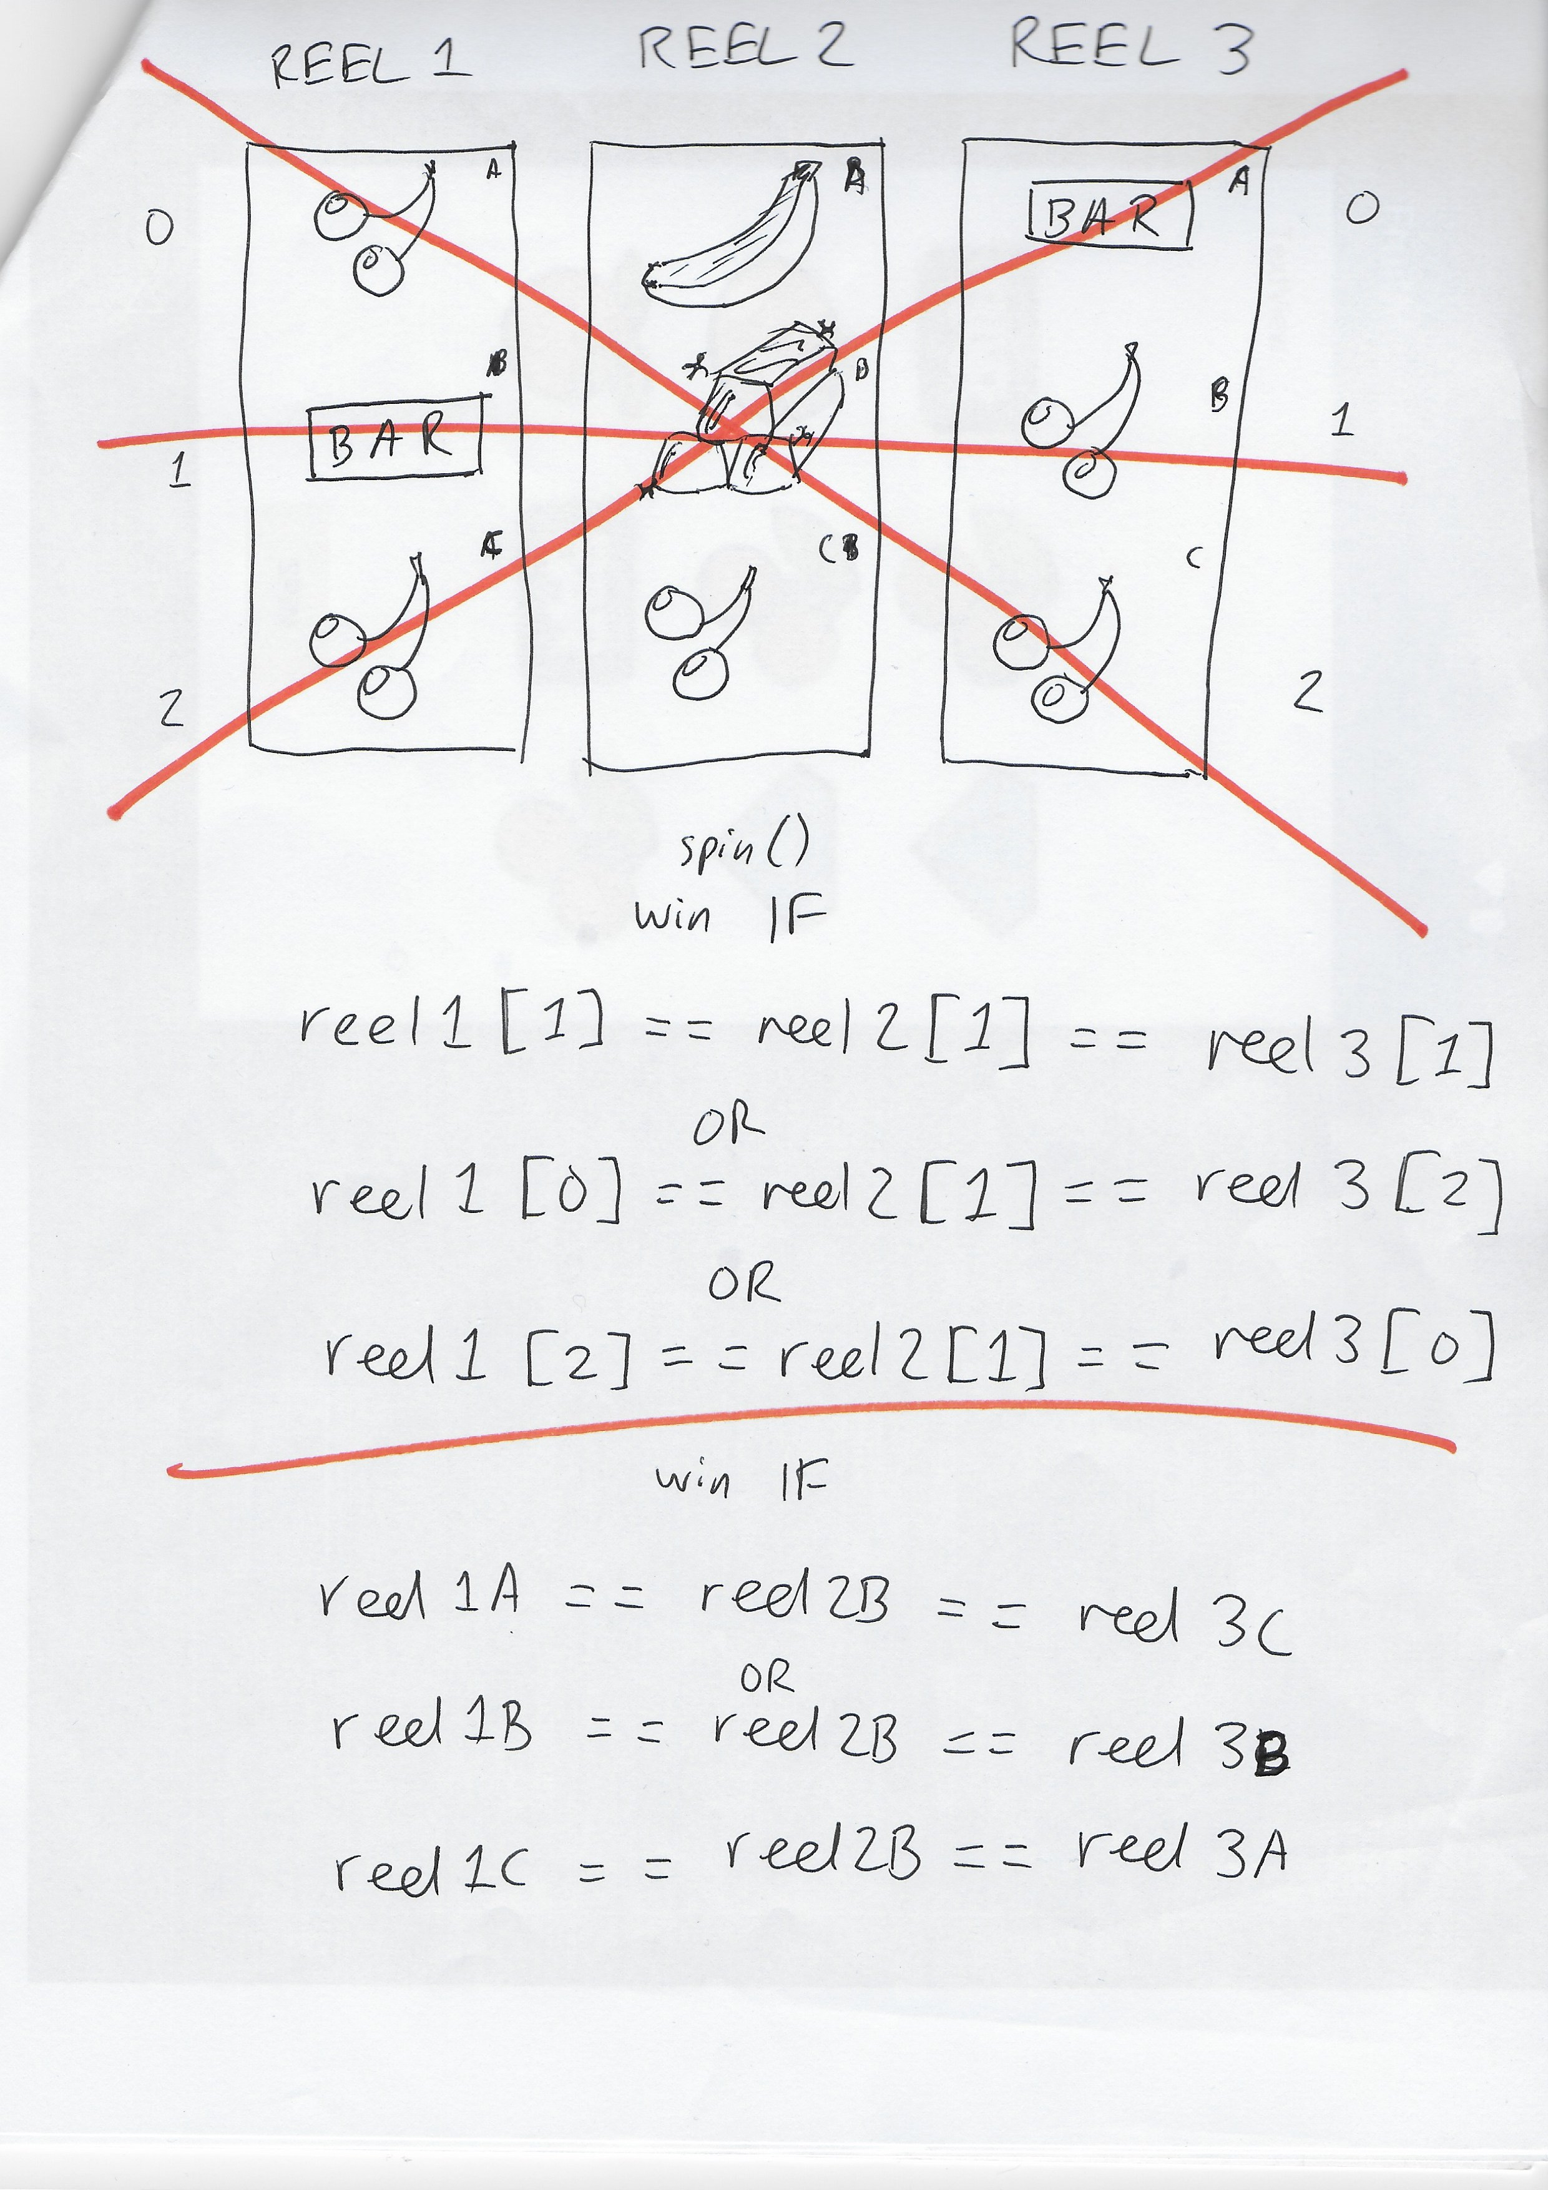

**P13 – User input**

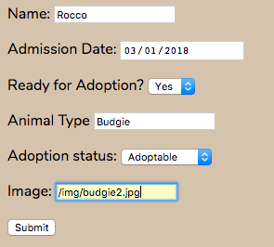

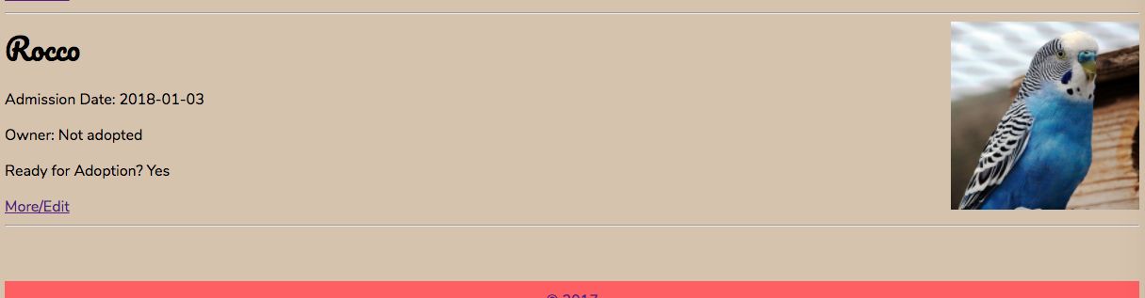

**P14/ P15 – Data persistence/ Results and feedback**

Initial state:



Request:

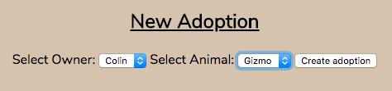

Result:

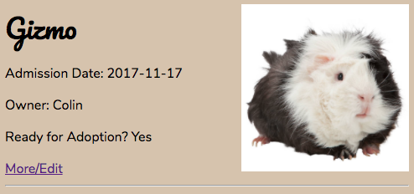

**P16 – API use**

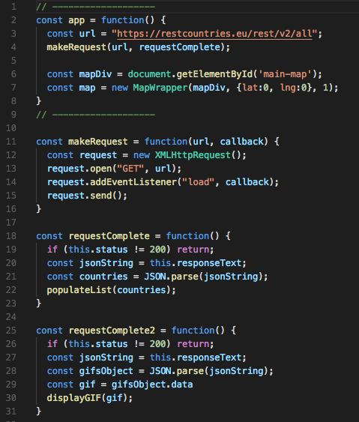

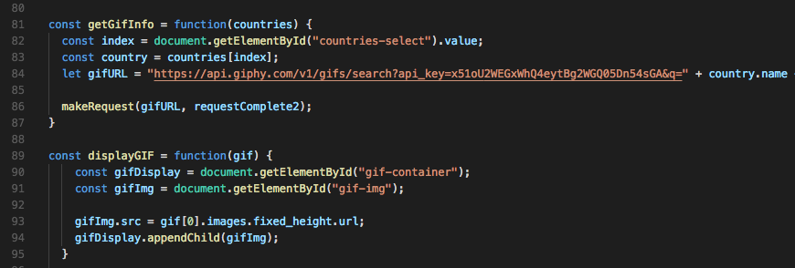

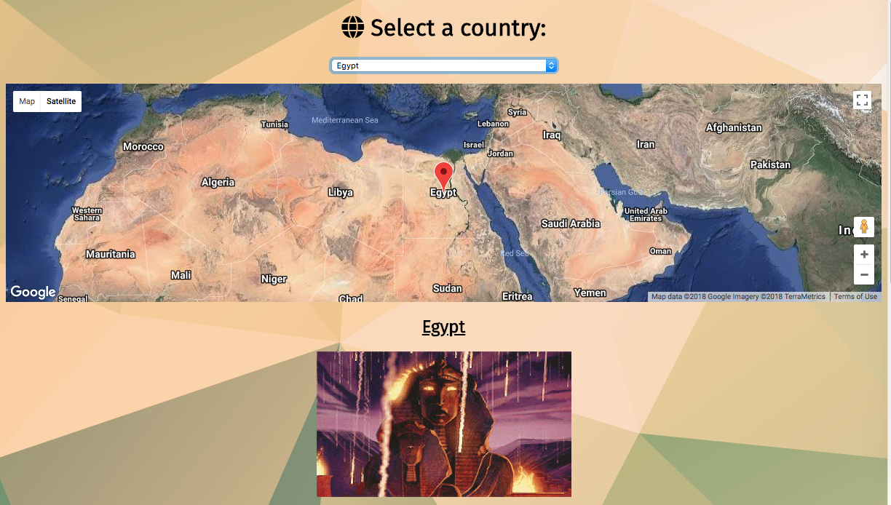

**P17 – Bug tracking report**

**P18 – Testing**

